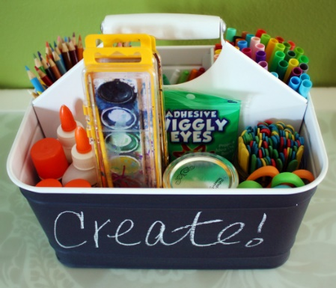

Skill 1: Play
Play is very important for children’s development
Parent or carer provides a shoebox or bag of toys or activities
Child leads the play and the parent or carer follows
Parent does not tell the child what to do or ask them to do anything
Parent or carer can join in if asked to
Parent or carer sits alongside the child during playtime
Parent gives the child their full and undivided attention
The playtime does have rules (covered in skill 2!!)

The mini-kit
A bag or shoe box with a selection of toys or activities
Chosen for the child by the parent or carer
These toys don’t have to be new but are not part of the child’s usual toy collection
No more than £5!!!

